TASK 3 – WEB APPLICATION SECURITY
ApexPlanet Software Pvt. Ltd.
Cybersecurity Internship
Raafia Muskaan
Objective
The objective of this task was to understand and perform web application security testing using DVWA (Damn Vulnerable Web Application). Various vulnerabilities including SQL Injection, Cross-Site Scripting (XSS), Cross-Site Request Forgery (CSRF), File Inclusion, Burp Suite request interception, and Security Header analysis were performed in a controlled environment to understand their impact and mitigation techniques.
Tools Used
- Kali Linux
- DVWA (Damn Vulnerable Web Application)
- Burp Suite Community Edition
- Mozilla Firefox
- Apache Web Server
- PHP
- MySQL
- curl
- Oracle VirtualBox
1. SQL Injection
Objective
To exploit SQL Injection vulnerabilities in DVWA and extract information stored inside the backend database.
SQL Injection occurs when user input is directly executed as part of an SQL query due to improper input validation. An attacker can manipulate database queries to retrieve unauthorized information.
Database Setup
Before performing SQL Injection, the DVWA database was initialized by clicking Create / Reset Database from the setup page.
This created the required database tables and sample records.
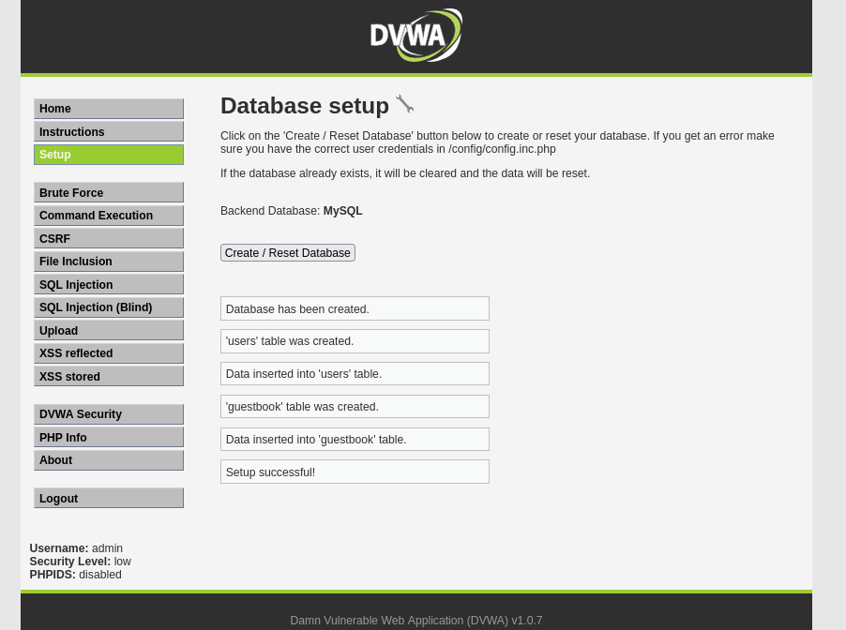
Normal Query
A normal User ID was entered into the SQL Injection page.
Example input:
1
The application returned only the corresponding user's information.
Observation
The application behaved normally by retrieving data associated with the entered User ID.
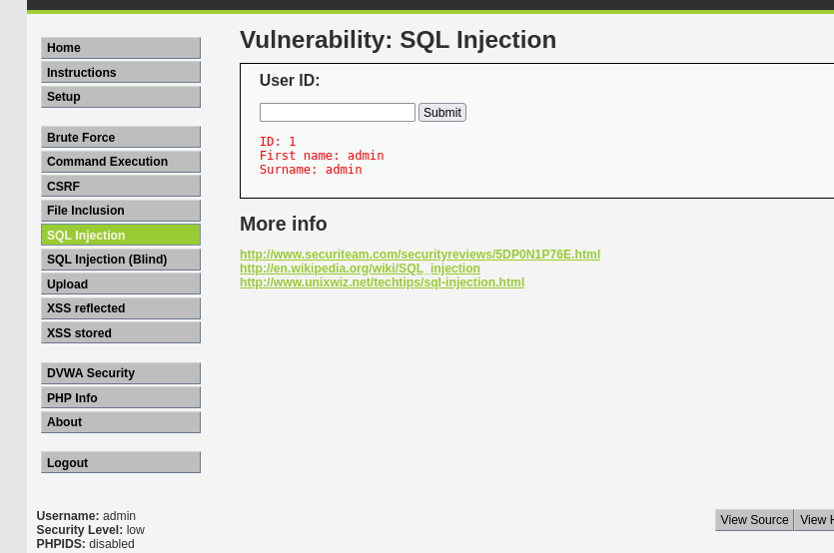
Performing SQL Injection
The following SQL Injection payload was entered:
1' OR '1'='1
The application returned details of all users stored in the database because the SQL condition always evaluated to TRUE.
Observation
The application was vulnerable because user input was directly appended into the SQL query without proper validation.
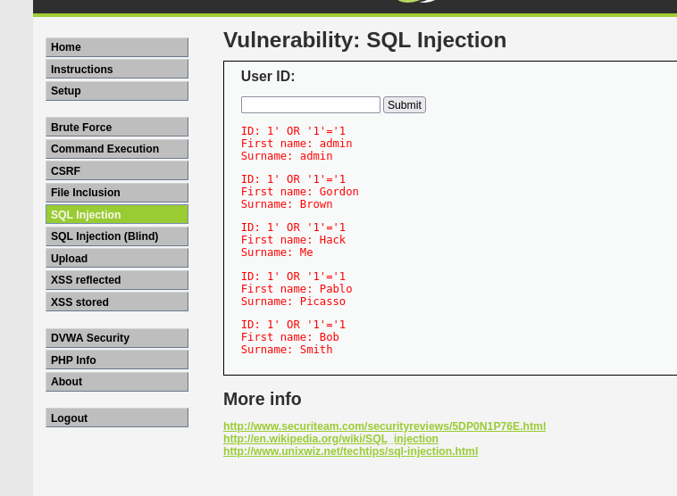
Extracting User Information
Additional SQL Injection payloads were used to enumerate database information.
The application displayed usernames and other sensitive information stored inside the database.
Observation
Sensitive information can be disclosed if SQL Injection vulnerabilities are left unpatched.
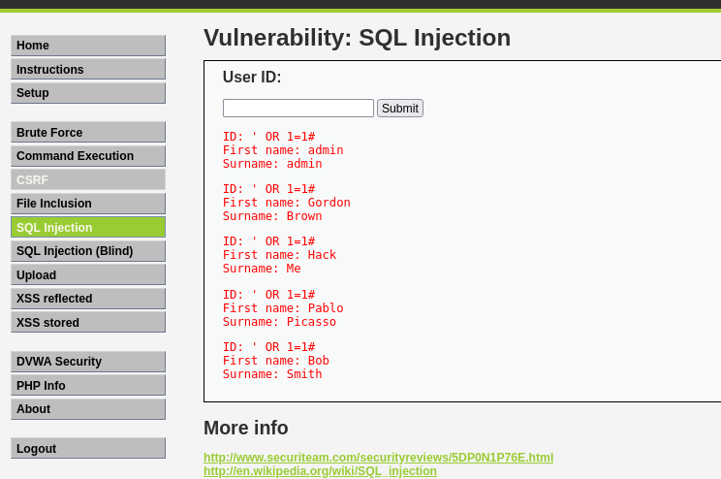
Database Version Enumeration
The database version was identified using:
1' UNION SELECT 1, version()#
Observation
Knowing the database version helps attackers identify publicly known vulnerabilities.
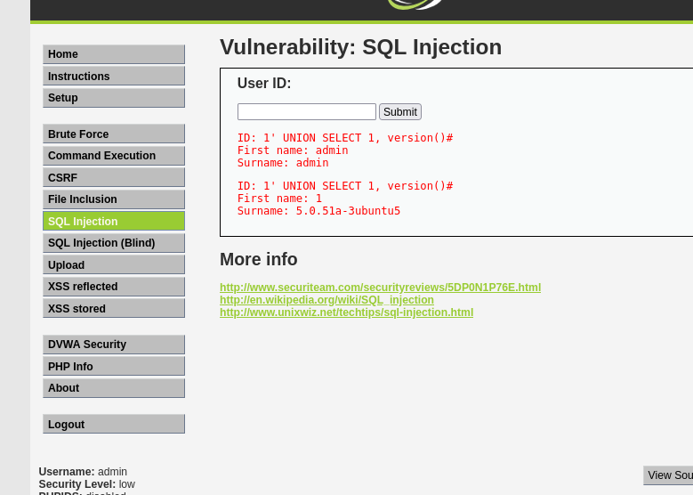
Database Name Enumeration
The current database name was extracted using:
1' UNION SELECT 1, database()#
Observation
The database name helps attackers perform targeted enumeration.
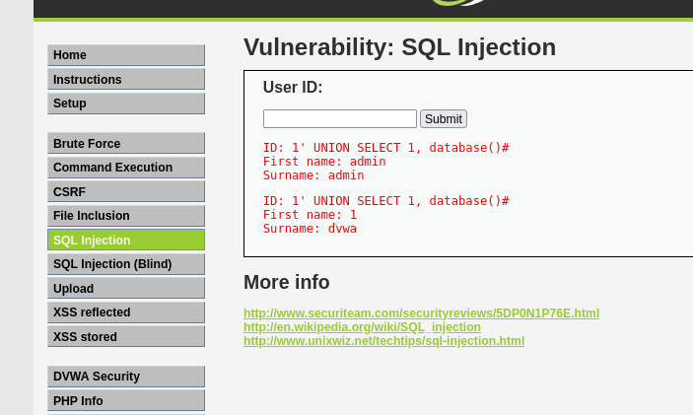
Table Enumeration
Database tables were enumerated using SQL Injection.
Example payload:
1' UNION SELECT table_name, table_schema FROM information_schema.tables#
Observation
Table enumeration provides attackers with the database structure required for further attacks.
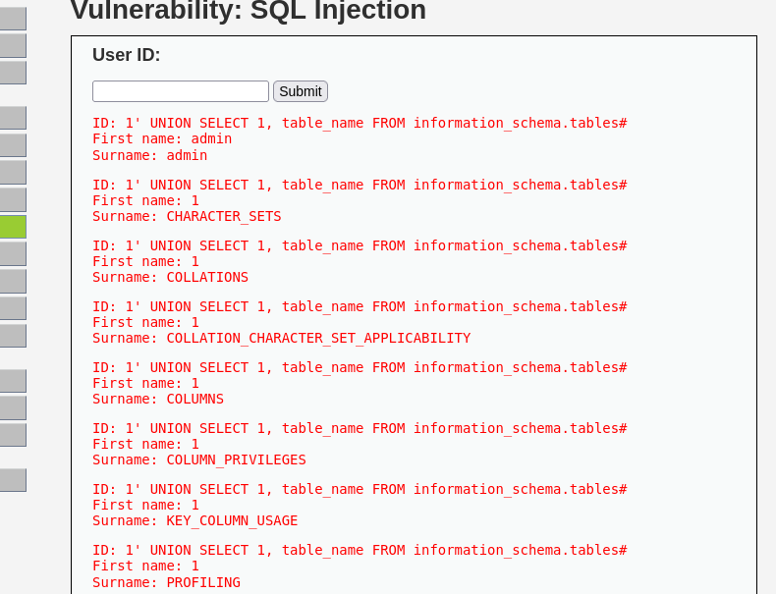
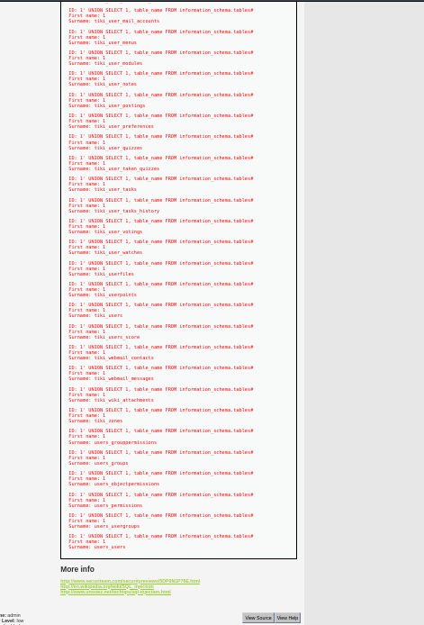
Extracting Usernames and Password Hashes
The following payload was used to retrieve usernames and password hashes.
1' UNION SELECT user,password FROM users#
Observation
Although passwords were hashed, attackers may attempt offline password cracking using specialized tools.
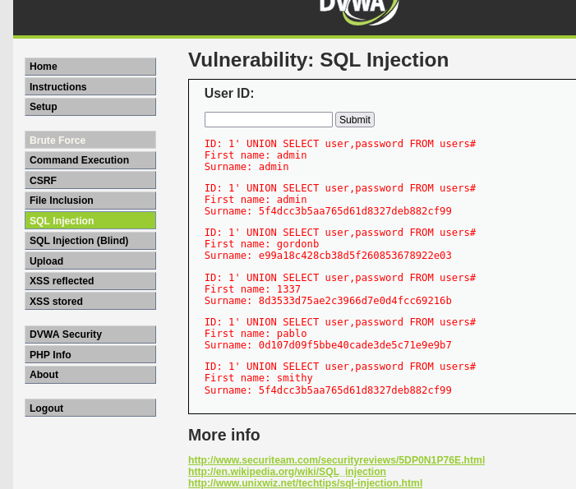
SQL Injection Prevention
The DVWA Security Level was changed to High.
The same SQL Injection payloads failed because stronger input validation and secure coding practices were implemented.
Mitigation
- Prepared Statements
- Parameterized Queries
- Input Validation
- Least Privilege Database Accounts
Observation
Prepared statements ensure user input is treated as data rather than executable SQL commands.
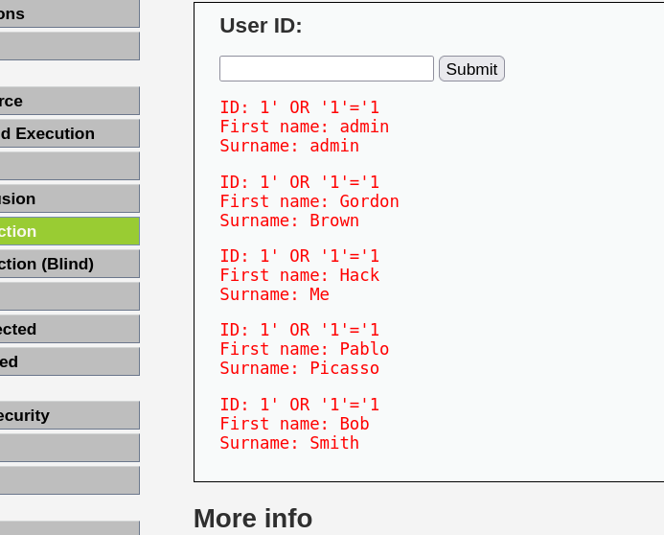
SQL Injection Summary
This exercise demonstrated how SQL Injection can expose confidential database information when applications fail to validate user input. It also highlighted the importance of secure coding practices to prevent such attacks.
2. Cross-Site Scripting (XSS)
Objective
The objective of this exercise was to understand how Cross-Site Scripting (XSS) vulnerabilities allow attackers to inject malicious JavaScript into web pages viewed by other users. DVWA was used to demonstrate both Reflected XSS and Stored XSS attacks.
Reflected Cross-Site Scripting
Reflected XSS occurs when malicious input submitted by a user is immediately reflected back by the web application without proper validation or output encoding.
The following JavaScript payload was entered into the input field:
<script>alert('XSS')</script>
When the application processed the request, the script executed in the browser and displayed an alert box.
Observation
The successful execution of the JavaScript code confirmed that the application was vulnerable to Reflected XSS. An attacker could exploit this vulnerability to steal session cookies, redirect users to malicious websites, or execute arbitrary JavaScript in the victim's browser.
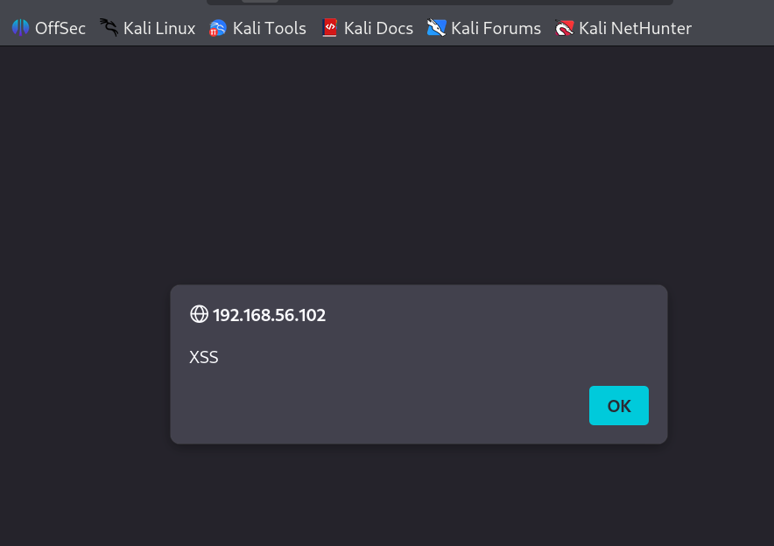
Stored Cross-Site Scripting
Stored XSS occurs when malicious JavaScript is permanently stored by the web application, usually inside a database. Every user viewing the affected page automatically executes the injected script.
The same payload was submitted through the Stored XSS module:
<script>alert('Stored XSS')</script>
After refreshing the page, the alert box appeared automatically, demonstrating that the malicious script had been saved by the application.
Observation
Unlike Reflected XSS, Stored XSS affects every user who accesses the compromised page. This makes it more dangerous because attackers can repeatedly execute malicious scripts without requiring users to click a specially crafted link.
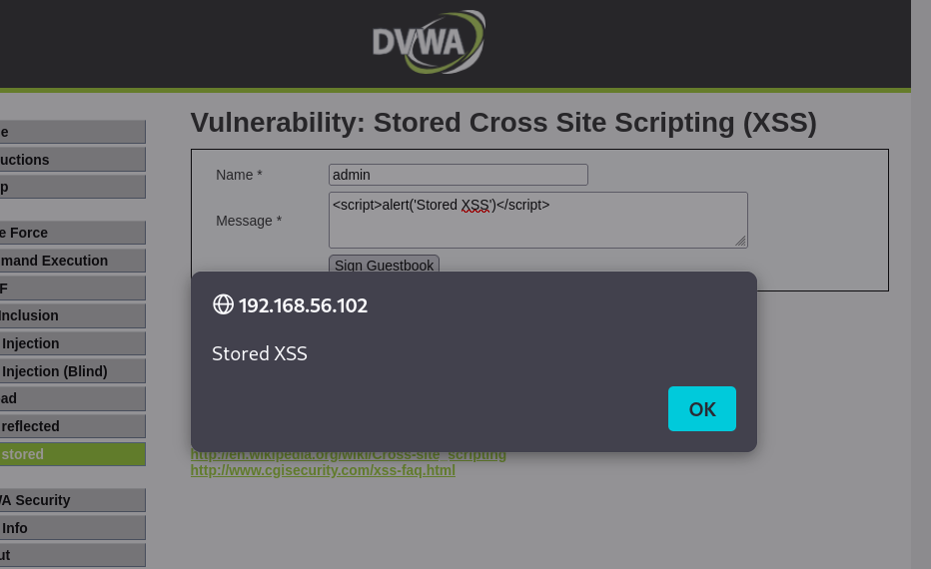
Mitigation
The following security measures help prevent Cross-Site Scripting attacks:
- Validate and sanitize all user inputs.
- Encode output before displaying user-supplied data.
- Implement Content Security Policy (CSP).
- Avoid inserting untrusted data directly into HTML pages.
- Use secure web development frameworks that automatically escape user input.
XSS Summary
The practical exercise demonstrated both Reflected and Stored Cross-Site Scripting vulnerabilities. The attacks highlighted how improper handling of user input can allow attackers to execute malicious JavaScript within a victim's browser, potentially leading to session hijacking, credential theft, and website defacement.

3. Cross-Site Request Forgery (CSRF)
Objective
The objective of this exercise was to understand how attackers can force authenticated users to perform unintended actions without their knowledge.
Cross-Site Request Forgery exploits the trust that a web application places in an already authenticated user's browser.
Password Change using CSRF
The DVWA CSRF module was opened, and a password change request was submitted without requiring additional user verification.
A new password was entered and submitted successfully.
Observation
The password was changed even though no additional confirmation was requested. This demonstrated that the application was vulnerable to Cross-Site Request Forgery.
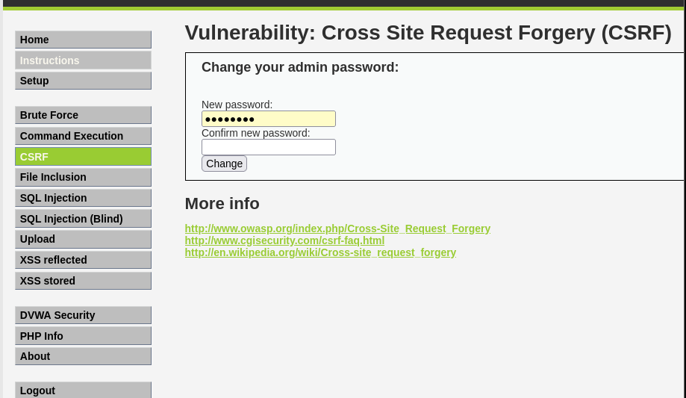
Successful Password Change
After submitting the request, DVWA confirmed that the password had been updated successfully.
Observation
This demonstrated how attackers could manipulate authenticated users into unknowingly performing sensitive actions.
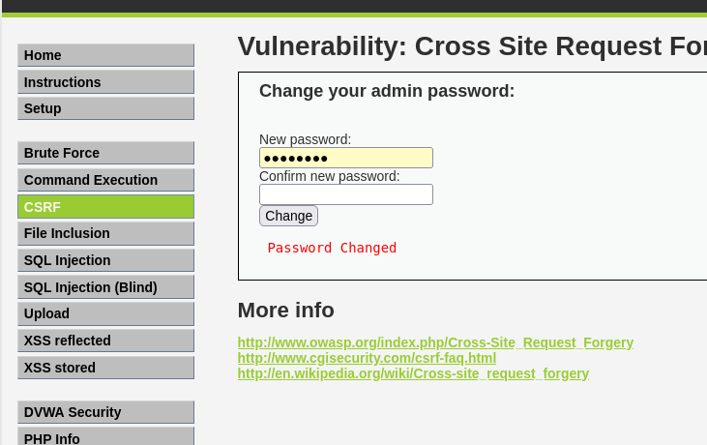
Verification
The application was logged out and then accessed again using the newly created password.
The login was successful, confirming that the password change had taken effect.
Observation
Successful authentication using the new password verified that the CSRF attack had modified the account credentials.
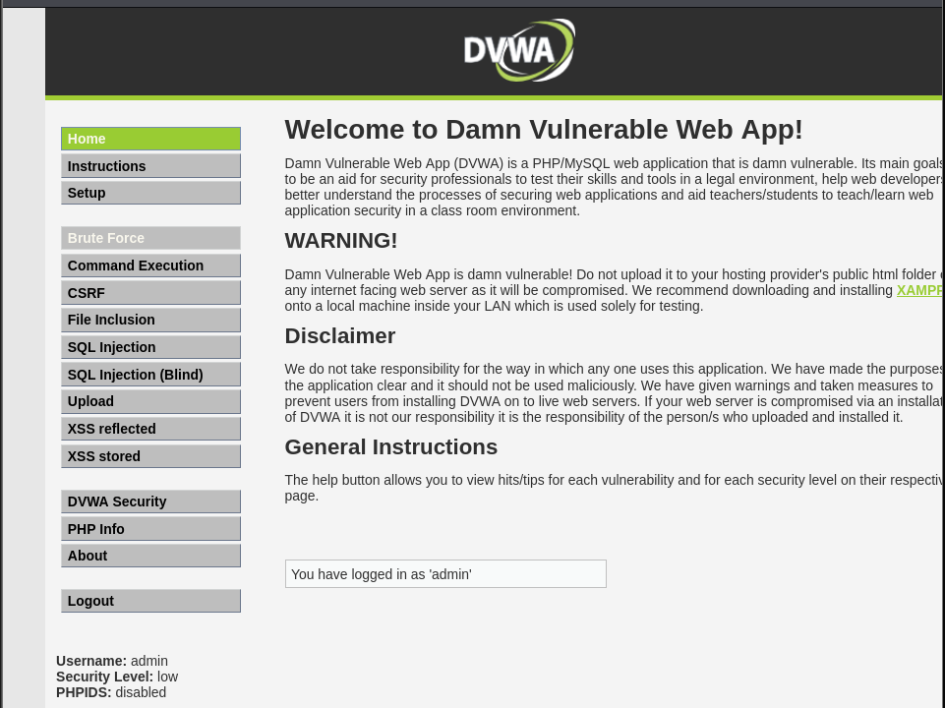
Mitigation
The following security mechanisms help prevent CSRF attacks:
- CSRF Tokens
- SameSite Cookies
- Re-authentication before sensitive operations
- Verification of Origin and Referer headers
- Multi-Factor Authentication (MFA) for critical actions
CSRF Summary
The experiment demonstrated how authenticated users can unknowingly execute malicious requests when proper CSRF protection mechanisms are absent. Implementing CSRF tokens and secure session management significantly reduces the risk of such attacks.

4. File Inclusion Vulnerability
Objective
The objective of this exercise was to understand how File Inclusion vulnerabilities allow attackers to access or execute unintended files on a web server. DVWA was used to demonstrate both Local File Inclusion (LFI) and Remote File Inclusion (RFI).
Local File Inclusion (LFI)
Local File Inclusion allows an attacker to access files stored on the target server by manipulating file path parameters.
The File Inclusion module in DVWA was opened and the following payload was used:
../../../../etc/passwd
The application displayed the contents of the Linux /etc/passwd file.
Observation
The successful display of the system file confirmed that the application was vulnerable to Local File Inclusion. Such vulnerabilities may expose sensitive system files and configuration information to attackers.
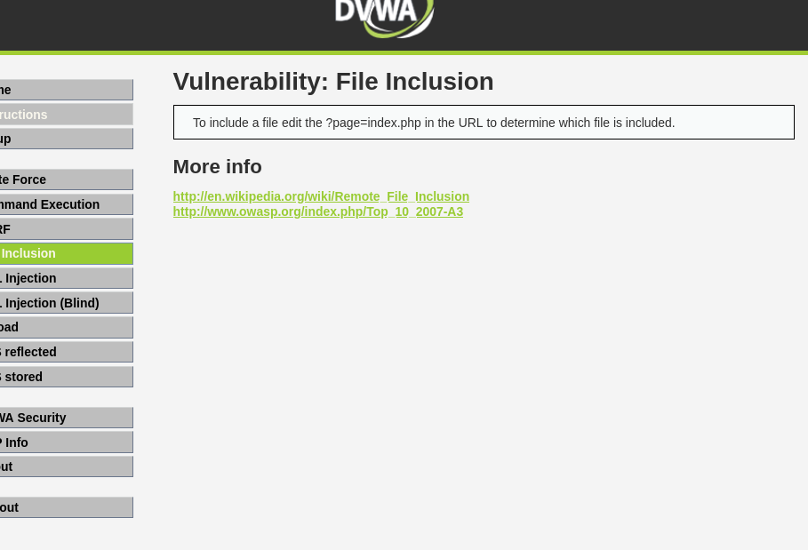
Displaying System Files
The contents of the /etc/passwd file were successfully displayed.
Observation
This confirmed that the application accepted unsanitized file paths, allowing attackers to read sensitive files from the operating system.
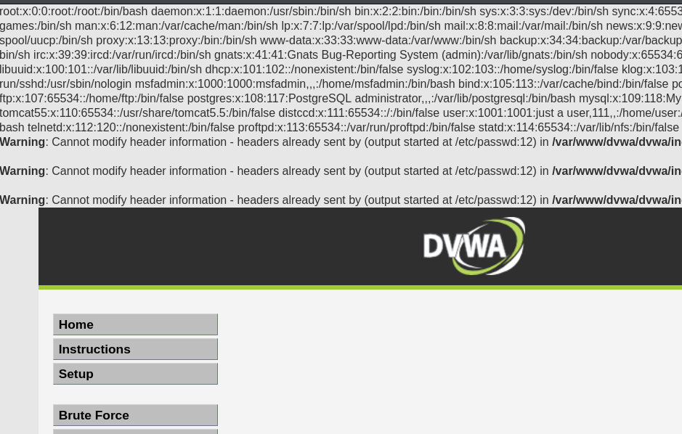
Remote File Inclusion (RFI)
Remote File Inclusion occurs when an application allows external files to be included and executed from remote servers.
The following URL was tested:
http://192.168.56.102/dvwa/vulnerabilities/fi/?page=http://example.com
Instead of loading the remote file, DVWA generated an error because remote URL inclusion was disabled in the PHP configuration.
Observation
The RFI attack was unsuccessful because the server configuration disabled remote file inclusion (allow_url_include = Off). This security setting prevents attackers from executing remote malicious files.
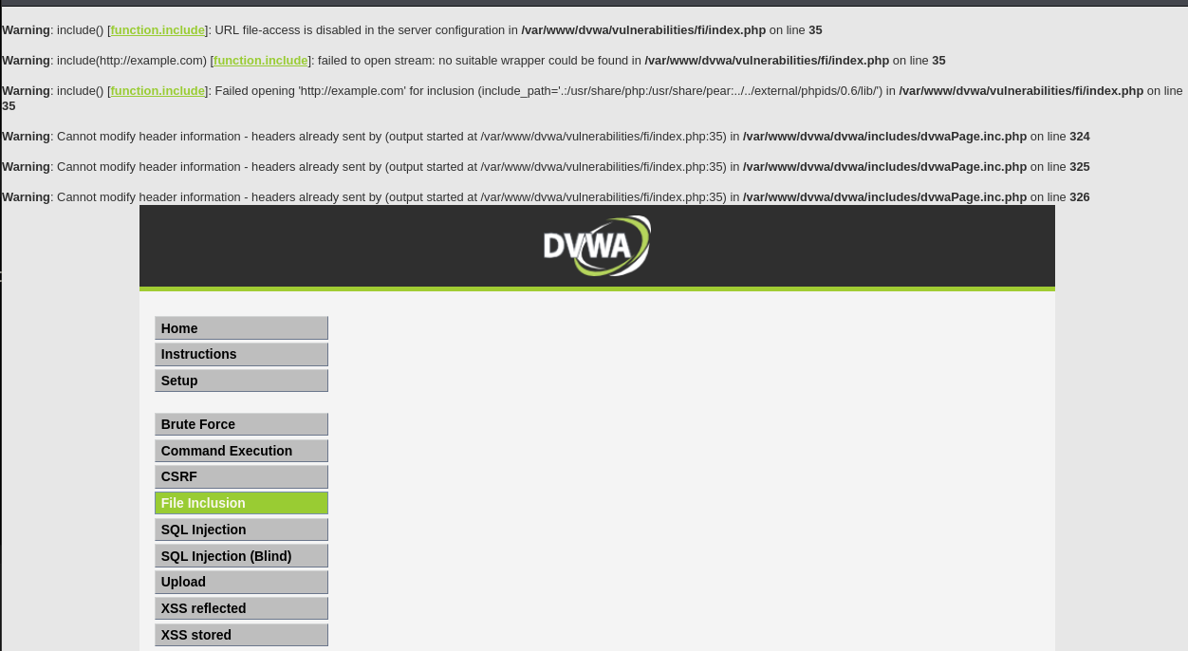

Mitigation
The following practices help prevent File Inclusion attacks:
- Validate and sanitize all user input.
- Restrict file access using whitelists.
- Disable remote file inclusion in PHP.
- Store sensitive files outside the web root.
- Apply the principle of least privilege.
File Inclusion Summary
This exercise demonstrated how improper handling of file paths can expose sensitive files or allow attackers to execute unauthorized content. Proper input validation and secure server configuration are essential to prevent File Inclusion vulnerabilities.
5. Burp Suite Advanced
Objective
The objective of this exercise was to understand how Burp Suite can be used to intercept, inspect, and manipulate HTTP requests before they reach the web application.
Burp Suite is one of the most widely used tools for web application security testing.
Starting Burp Suite
Burp Suite Community Edition was launched in Kali Linux and configured to intercept browser traffic.
Mozilla Firefox was configured to use Burp Suite as its proxy.
Observation
Burp Suite successfully captured HTTP requests between the browser and DVWA.
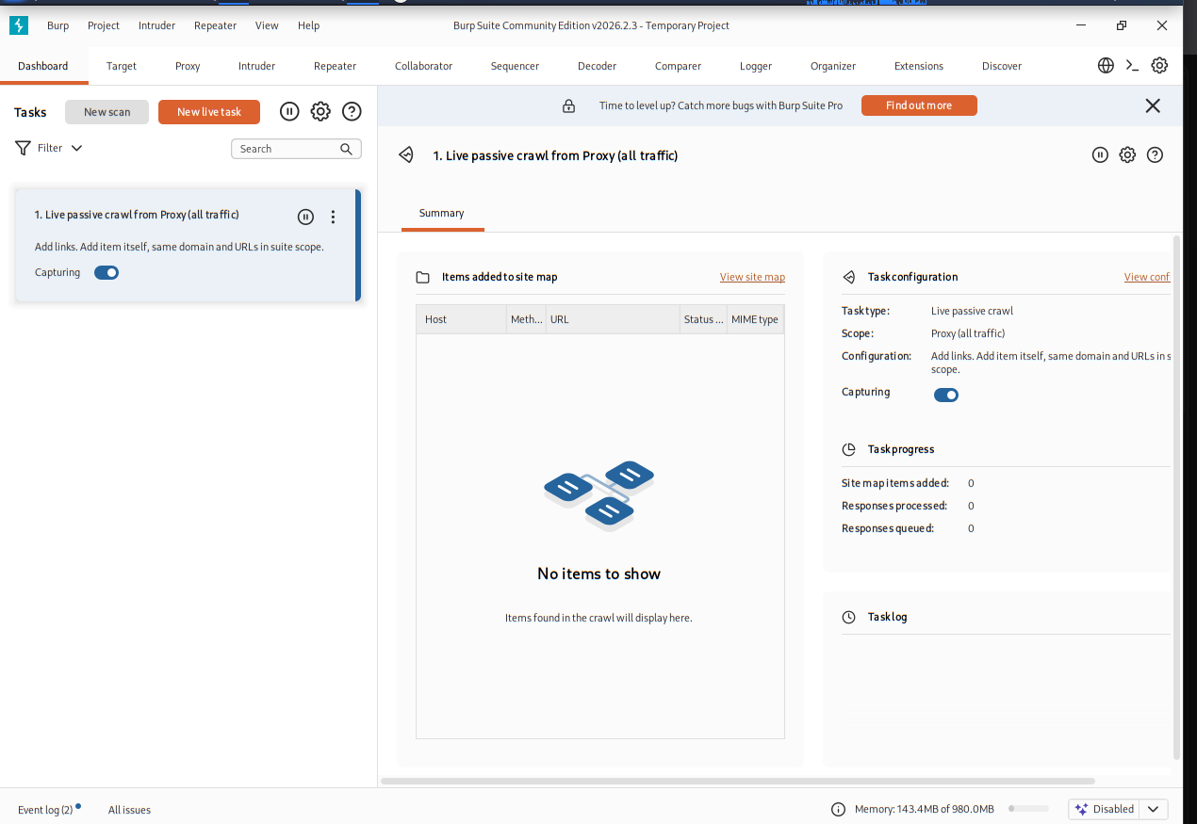
Intercepting Login Requests
The DVWA login page was opened while Burp Intercept was enabled.
The login request was successfully captured before reaching the web server.
Observation
Request interception allows security testers to inspect and modify HTTP traffic before it is processed by the application.
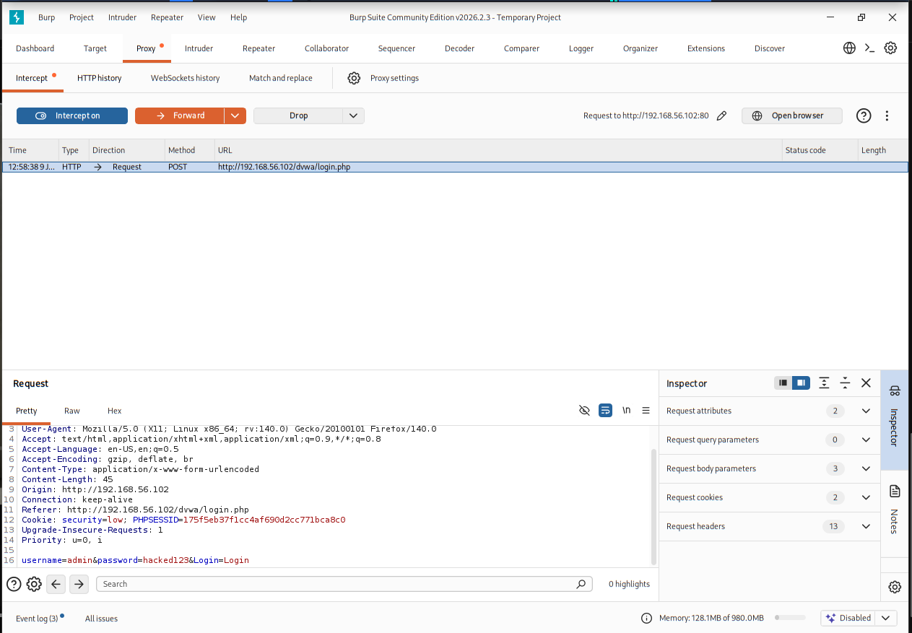
Request Modification
The intercepted login request was modified before being forwarded.
Observation
Modifying intercepted requests demonstrates how attackers may tamper with parameters if proper server-side validation is not implemented.
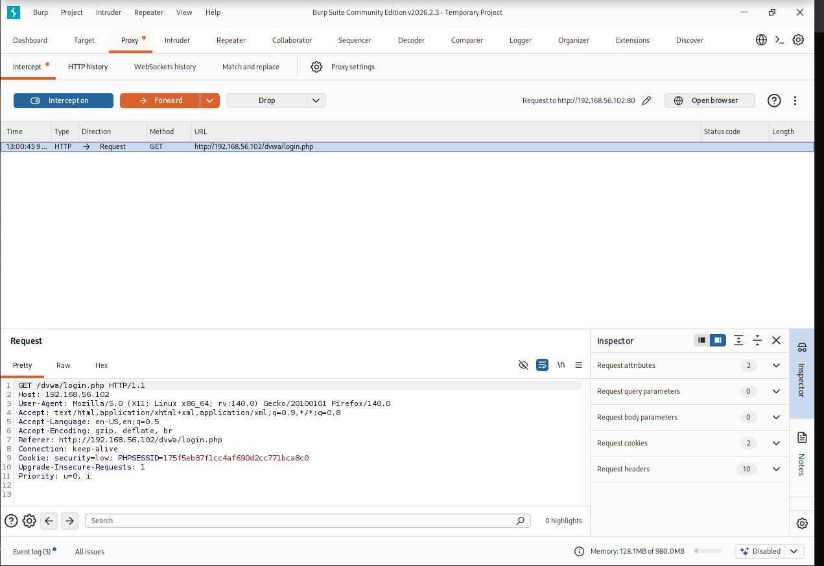
Burp Intruder Configuration
The intercepted request was sent to the Intruder module.
Payload positions were configured to identify the parameters that would be tested.
Observation
Intruder automates repeated testing of application parameters using multiple payloads.
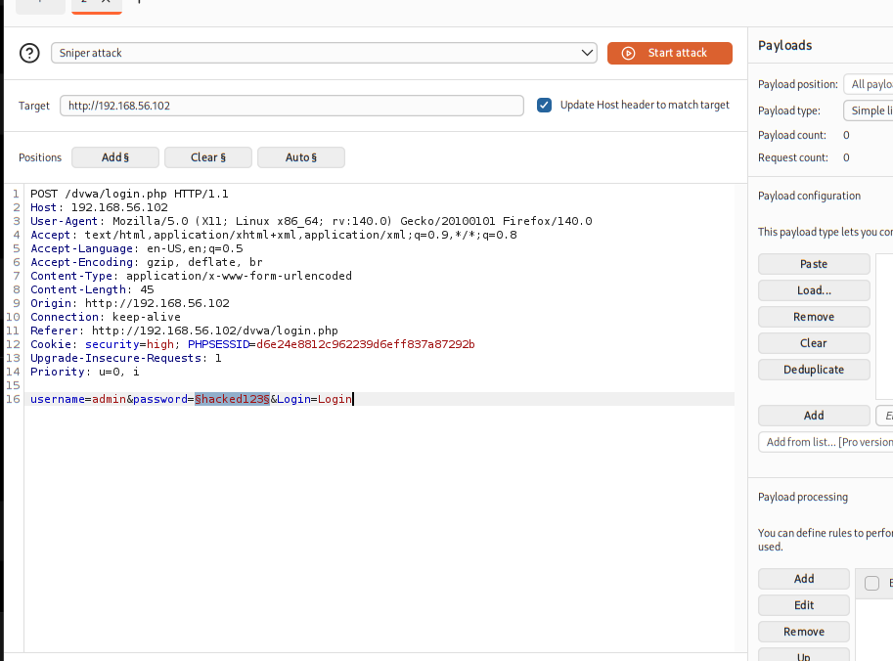
Payload Configuration
A password payload list was configured inside Burp Intruder.
Observation
Payloads are used to automate testing such as brute-force attacks, fuzzing, and input validation testing.
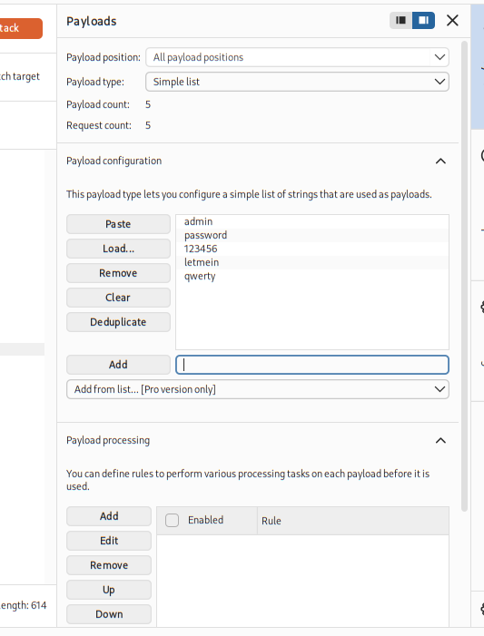
Burp Community Edition Limitation
When attempting to start the Intruder attack, Burp Suite Community Edition displayed its usage limitation.
Although the full automated attack was not available, the Intruder configuration process was successfully demonstrated.
Observation
The Community Edition restricts certain automated attack features; however, request interception and Intruder configuration remain available for learning purposes.
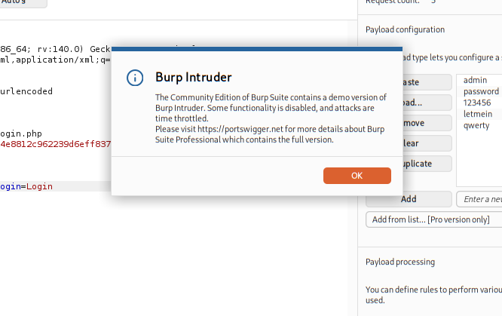
Burp Suite Summary
This exercise demonstrated the use of Burp Suite for intercepting, inspecting, and modifying HTTP requests. It also introduced Burp Intruder for automated request testing and highlighted the limitations of the Community Edition while reinforcing the importance of validating user input on the server side.

6. Web Security Headers Analysis
Objective
The objective of this exercise was to analyze the HTTP security headers returned by the web application and understand their role in protecting web applications against common attacks such as Cross-Site Scripting (XSS), Clickjacking, MIME-type confusion, and protocol downgrade attacks.
HTTP Header Inspection using curl
The following command was executed from the Kali Linux terminal to inspect the HTTP response headers returned by the DVWA application.
Command
curl -I http://192.168.56.102/dvwa
The server returned standard HTTP headers including server information and content type.
Observation
The HTTP response did not include important security headers such as:
- Content-Security-Policy (CSP)
- X-Frame-Options
- X-Content-Type-Options
- Strict-Transport-Security (HSTS)
The absence of these headers makes web applications more vulnerable to attacks such as Cross-Site Scripting, Clickjacking, and MIME-type sniffing.
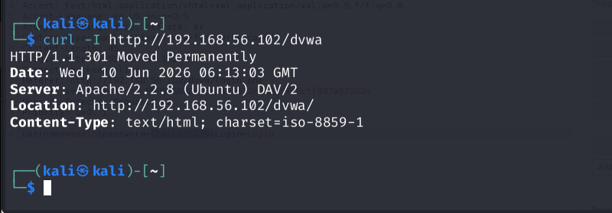
SecurityHeaders.com Analysis
The application was tested using SecurityHeaders.com.
Since the target application was hosted on a private VirtualBox Host-Only network using the IP address 192.168.56.102, the website was unable to scan the application because private IP addresses are not publicly accessible.
Observation
Although the online scanner could not analyze the application, manual inspection using the curl command successfully identified the missing HTTP security headers.
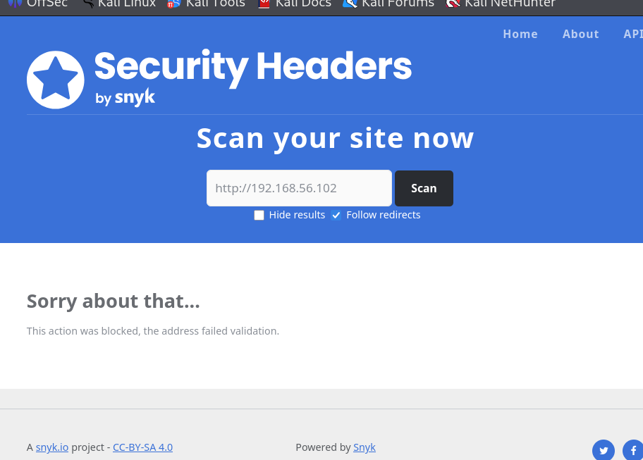
DVWA Security Configuration
The DVWA security level was changed to Low to demonstrate and test multiple web application vulnerabilities.
Observation
Different security levels in DVWA simulate how secure coding practices affect vulnerability exploitation. Lower security levels intentionally disable protections to support cybersecurity training.
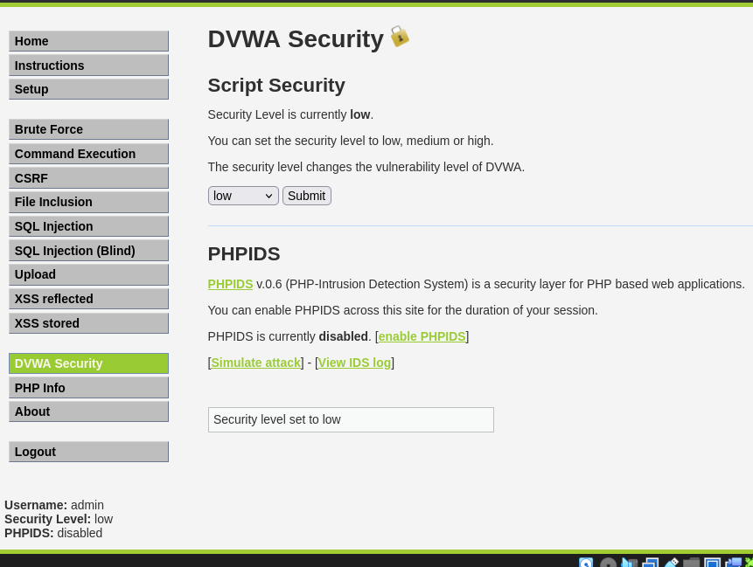
Findings
The practical exercises demonstrated several common web application vulnerabilities that exist due to insecure coding practices and poor security configurations.
The following vulnerabilities were successfully demonstrated:
- SQL Injection
- Reflected Cross-Site Scripting (XSS)
- Stored Cross-Site Scripting (XSS)
- Cross-Site Request Forgery (CSRF)
- Local File Inclusion (LFI)
- Remote File Inclusion (RFI) Attempt
- HTTP Request Interception using Burp Suite
- Security Header Analysis
The experiments highlighted how attackers can exploit insecure applications and emphasized the importance of secure coding practices, proper input validation, secure session management, and appropriate server configuration.

Mitigation Summary
The following security practices help protect web applications from the demonstrated attacks:
SQL Injection
- Use prepared statements and parameterized queries.
- Validate and sanitize user input.
- Apply the principle of least privilege for database accounts.
Cross-Site Scripting (XSS)
- Validate all user input.
- Encode output before displaying user-supplied data.
- Implement Content Security Policy (CSP).
Cross-Site Request Forgery (CSRF)
- Use CSRF tokens.
- Verify the Origin and Referer headers.
- Require re-authentication for sensitive actions.
File Inclusion
- Validate file paths.
- Use whitelisting for permitted files.
- Disable remote file inclusion (allow_url_include = Off).
Burp Suite Findings
- Validate all requests on the server side.
- Never trust client-side input.
- Use secure authentication and session management.
Security Headers
Implement important HTTP security headers such as:
- Content-Security-Policy
- X-Frame-Options
- X-Content-Type-Options
- Strict-Transport-Security
- Referrer-Policy
Learning Outcomes
Through this task, the following practical skills were developed:
- Understood common OWASP web application vulnerabilities.
- Performed SQL Injection attacks and extracted database information.
- Demonstrated Reflected and Stored XSS attacks.
- Performed Cross-Site Request Forgery testing.
- Exploited Local File Inclusion and analyzed Remote File Inclusion.
- Used Burp Suite to intercept and analyze HTTP requests.
- Inspected HTTP security headers.
- Learned secure coding practices and mitigation techniques for common web application vulnerabilities.
Conclusion
This task provided practical experience in identifying and analyzing common web application vulnerabilities using DVWA in a controlled laboratory environment. Multiple attacks including SQL Injection, Cross-Site Scripting, Cross-Site Request Forgery, File Inclusion, and HTTP request interception were successfully demonstrated using industry-standard cybersecurity tools.
The exercises emphasized the importance of secure coding practices, proper input validation, secure session management, and defensive security mechanisms to protect modern web applications. Overall, this task strengthened practical knowledge of web application security testing and provided valuable experience with techniques commonly used in ethical hacking and penetration testing.

